CSE 210 W05 – Inheritance Explained
Thomas A Gibb
- Explain the meaning of Inheritance.
  - Provides a method of defining common functions at the base level that can be re-utilized in sub-functions.
  - By using these common functions, it simplifies the ability to maintain and improve the operation of sub-functions without having to do any code re-design within them.
- Highlight the benefit of Inheritance.
  - Provides a common point to accomplish the update to functions that are utilized across the sub-functions.
- Provide an application of Inheritance.
  - When a timer is designed that can be utilized across sub functions, it simplifies the extent of the design and reduces waste and eliminates complexity.
- Use a code example of Inheritance from the program you wrote.
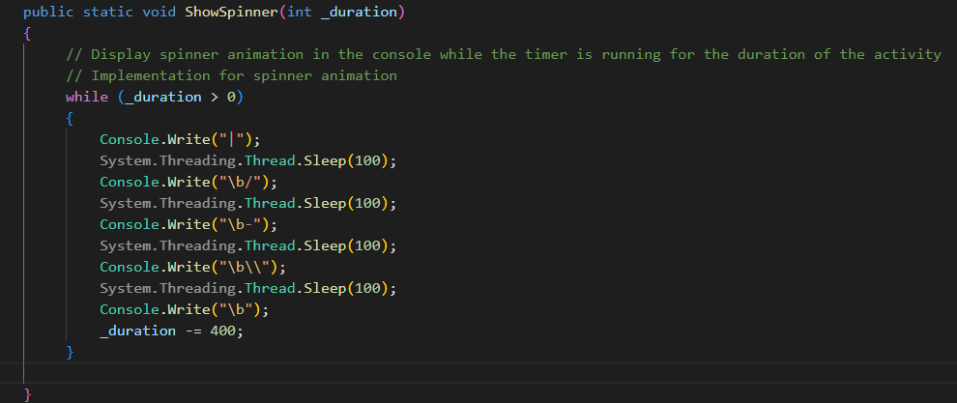

- Thoroughly explain these concepts.
  - It was an interesting concept to build and made for some awesome code that I’m able to re-utilize across several functions to allow me to display a timer that will decrement from a pre designated time frame. I do not need re-build this spinner function in any of the sub functions because I can call it from the base activity and make it a really useful concept.
  - I’ve been looking at this and going, wow, this would and will be very useful as it allows us to build programs that are easier to debug, make modifications to and allows me to see and optimize my complexity and functional durability as well as limit my exposure to possible compromise.

